**Lab 2: Elementary Programming**

**Question 1:**

Write a program that reads a Celsius degree from the console and converts it to Fahrenheit and displays the result. The formula for the conversion is as follows:   fahrenheit = (9 / 5) * celsius + 32

Here is a sample run of the program:

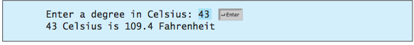

**Question 2:**

Write a program that reads in an investment amount, the annual interest rate, and the number of years, and displays the future investment value using the following formula:

***futureInvestmentValue* = *investmentAmount* * (1 + *monthlyInterestRate*)*numberOfMonths***

For example, if you enter the amount **1000**, an annual interest rate of **4.25%**, and the number of years as **1**, the future investment value is **1043.33**.

Here is a sample run:

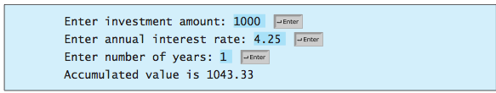

**Question 3:**

Write a program that reads an integer between **0** and **1000** and adds all the digits in the integer. For example, if an integer is **932**, the sum of all its digits is **14**. (Hint: Use the **%** operator to extract digits, and use the **//** operator to remove the extracted digit. For instance, **932 % 10 = 2** and **932 // 10 = 93**.)

Here is a sample run:

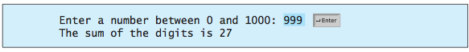

**Question 4:**

Body mass index (BMI) is a measure of health based on weight. It can be calculated by taking your weight in kilograms and dividing it by the square of your height in meters. Write a program that prompts the user to enter a weight in pounds and height in inches and displays the BMI. Note that one pound is **0.45359237** kilograms and one inch is **0.0254** meters.

Here is a sample run:

